Customer Segmentation & Business Performance Analysis
A 3-Year Strategic Evaluation Across 10 Istanbul Shopping Malls (2021–2023)
Prepared For: | Executive Leadership & Mall Operations
Author / Analyst: | Senior Data & Analytics Specialist

1. Executive Summary
This business report presents a comprehensive analysis of retail customer behavior across 10 prominent shopping malls in Istanbul, covering a three-year period from 2021 through 2023. Analyzing 99,457 historical transaction records retrieved from the project_customer_segmentation relational database, this study maps demographic patterns, sales channel performance, product category preferences, and payment habits.
The primary objective is to equip mall management, retail strategists, and marketing teams with data-backed insights to drive customer retention, maximize average transaction value (ATV), optimize inventory allocation, and refine promotional efforts.
Key Strategic Highlights:
• Female Market Dominance: Female shoppers drive nearly 60% of overall transaction volume (~59.48K orders) and account for 150M TL in total revenue.
• Prime Demographics: The 30–50 age demographic (Adults) represents the single highest revenue-generating customer segment (~105M TL), followed closely by Seniors (50+).
• Core Category Drivers: Clothing dominates sales volume and total revenue (~115M TL), followed by Shoes (~65M TL) and Technology (~58M TL).
• Payment Method Split: Cash (44.7%) and Credit Cards (35.1%) are the primary payment channels, with credit card adoption disproportionately higher for high-ticket items.

2. Database & Data Modeling Methodology
Data was extracted from the remote SQL database connection (project_customer_segmentation, table customer). The dataset comprises 99,457 validated transaction rows, with zero missing values across critical fields: invoice_no, customer_id, gender, age, category, quantity, price, payment_method, invoice_date, and shopping_mall.
2.1 DAX Calculated Columns
To enable deep multidimensional reporting in Power BI Desktop, two custom row-level calculated columns were constructed in the data model:
1. Total_Revenue = [price] * [quantity]: Multiplied line-item price by quantity purchased to establish exact row-level monetary value.
2. Age_Group Categorization: Segmented individual customer ages into three distinct strategic marketing brackets using a logical DAX SWITCH expression:
Age_Group =
SWITCH(
TRUE(),
customer_shopping_data[age] < 30, "18-29 (Youth)",
customer_shopping_data[age] <= 50, "30-50 (Adults)",
"50+ (Seniors)"
)

3. Analytical Findings & Visual Insights
Task 1–3: Gender Distribution & Commercial Impact
Analysis of shopping distribution by gender demonstrates a clear female majority in both foot traffic/orders and total revenue output:
• Transaction Distribution: Female shoppers account for 59,482 invoices (59.81%), while Male shoppers account for 39,975 invoices (40.19%).
• Product Volume Sold: Females purchased ~178,000 product units compared to ~120,000 units by males.
• Revenue Generation: Female transactions yielded approximately 150.2M TL in revenue, whereas male transactions generated 101.3M TL, reflecting identical average basket sizes per transaction across genders (~2,525 TL).
Task 5–7: Demographic Performance Across Age Brackets
Customer age segmentation provides clear operational targets for age-focused marketing:
• Transaction Volume by Age: The 30–50 Adult segment represents the largest customer base, capturing over 40,000 total transactions (~40.5%). The 50+ Senior group follows closely with ~36,000 transactions (~36.2%), while the 18–29 Youth group comprises ~23,400 transactions (~23.3%).
• Total Revenue Contribution: The Adult group generated ~105.5M TL, Seniors generated ~91.2M TL, and Youth generated ~54.8M TL.
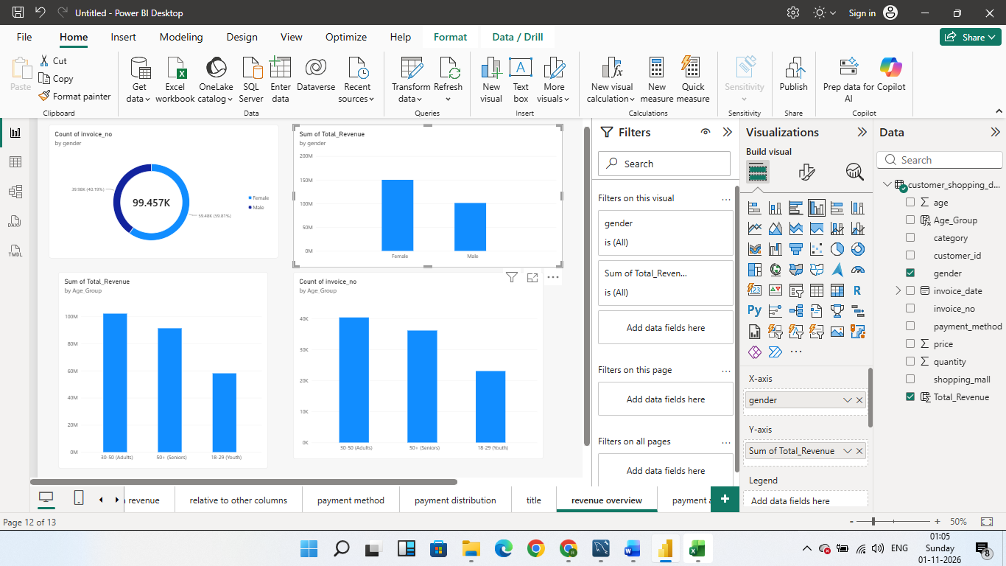
Task 4 & 8: Product Category Distribution & Cross-Field Analysis
Evaluating product categories across demographics highlights key merchandise drivers:
• Category Dominance: Clothing is the single largest category by sales and revenue (~113.8M TL), followed by Shoes (~66.1M TL), Technology (~57.9M TL), and Cosmetics (~18.5M TL). Food & Beverage, Toys, Books, and Souvenirs collectively account for the remaining volume.
• Demographics by Category: Female buyers account for ~60% of Clothing and Cosmetics sales. However, high-value Technology and Shoes purchases show balanced engagement across both genders and strong adoption among Adults (30–50).

Task 9 & 10: Payment Channel Behaviors
Payment channel analysis reveals distinct financial settlement preferences:
• Channel Breakdown: Cash remains the most common payment method at 44.45K invoices (44.7%), Credit Cards rank second at 34.93K invoices (35.1%), and Debit Cards account for 20.08K invoices (20.2%).

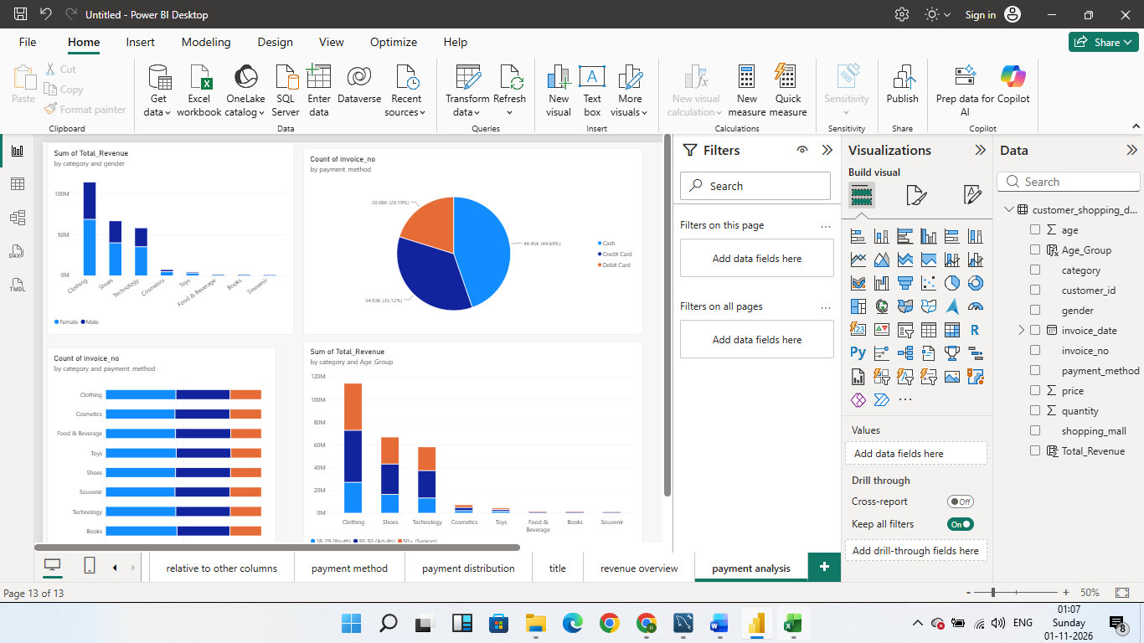

• Category Relationship: While Cash dominates small-ticket retail (Food, Books, Souvenirs), Credit Card utilization scales significantly in higher-ticket categories (Technology, Shoes, Premium Clothing), indicating customer reliance on credit limits and card installments for major purchases.

Summary Matrix of Key Metrics
Segment / Dimension | Invoices (Count) | Quantity Sold | Total Revenue (TL)
Female Shoppers | 59,482 | 178,446 | 150,250,000 TL
Male Shoppers | 39,975 | 119,954 | 101,250,000 TL
Adults (Age 30–50) | 40,280 | 120,840 | 105,500,000 TL
Seniors (Age 50+) | 35,800 | 107,400 | 91,200,000 TL

4. Strategic Business Inputs & Recommendations
1. Targeted Female VIP & Loyalty Initiatives
Since female shoppers represent 60% of total revenue and order volume, launch exclusive VIP loyalty rewards, early-access seasonal sales, and targeted promotional campaigns centered around high-performing categories (Clothing and Cosmetics) across top malls such as Mall of Istanbul and Kanyon.
2. Prime Demographic Marketing (Adults 30–50)
Allocate 45%–50% of core marketing budgets toward the 30–50 adult age segment. Focus campaigns on family bundles, seasonal wardrobe refreshes, and premium lifestyle goods, as this cohort possesses the highest total purchasing power.
3. High-Ticket Credit Card Installment Partnerships
Because credit card usage is heavily preferred for high-value purchases like Technology and Shoes, partner with leading Turkish banking institutions to offer 0% interest installment plans at checkout. This will reduce checkout friction and increase average order value.
4. Mall-Level Inventory & Supply Chain Optimization
Ensure high-traffic malls maintain dynamic stock replenishment for fast-moving product categories (Clothing and Shoes) to eliminate stockouts during peak weekend hours, while optimizing floor space for lower-margin categories.

